Michael flint
  - AKOSH Safety Consultant
  - Alaska Occupational Safety & Health
  - michael.flint@alaska.gov 907-269-4951
2022.03.08
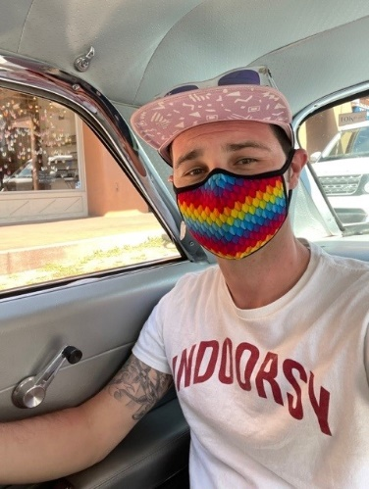
About Michael:
My name is Michael Flint. I am an AKOSH Safety Consultant and I have been with AKOSH Consultation and training for the last year. Prior to working for AKOSH I worked with a local tourism company and managed a motorcoach transportation division and commercial driver safety and training program. Going further back I served in the US Navy aboard the USS John C Stennis. My passion for safety began when I joined the Navy in 2008 and I very much enjoy getting the opportunity to help the community and specifically employees of small businesses. I have lived in Alaska for the last 10 years and love taking my dogs outdoors, spending time with my pot-belly pig Hamilton, and playing whatever new Nintendo Switch game is available. Think a letter that looks this good has to be difficult to format? Think again! To easily apply any text formatting you see in this document with just a tap, on the Home tab of the ribbon, check out Styles.
Topic:
The training I will be conducting will be covering what services AKOSH offers to businesses as well as some of the cooperative programs that employers who wish to go above the basic standards of safety can chose to join. The training will highlight some of the differences between AKOSH Enforcement Officers and AKOSH Consultation Officers as well as some of the benefits to working with AKOSH Consultation. The training should take around 30 to 40 minutes including questions.

