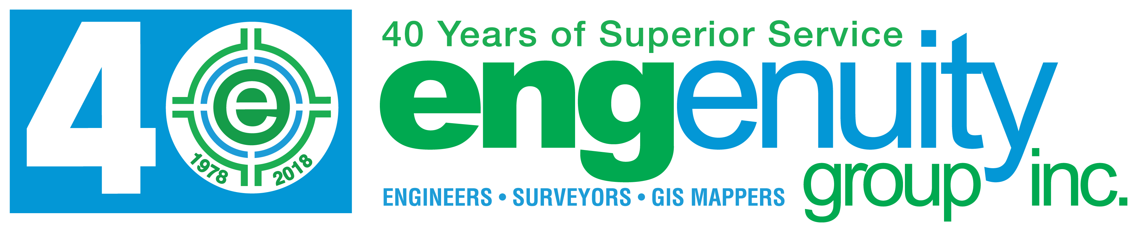

**If interested, please email** [**bjackson@engenuitygroup.com**](mailto:bjackson@engenuitygroup.com) **with an attached resume and contact information.**

***Project Surveyor***

**Job Description**

We are seeking an individual with great work ethic and an ability to motivate themselves as well as coworkers towards meeting project deadlines with minimal oversight in a fast paced environment. The candidate must display problem solving skills while always looking out for the clients’ best interest. The desired candidate will have experience in design surveys, construction staking, record drawings, boundary and topographic survey, sketch and legal descriptions, plat preparations and elevation certificates. Each day will present new and exciting jobs and opportunities to interact with various clients.

**Key Responsibilities**

Ability to make accurate and neat drawings, knowledge of advanced mathematics and surveying, knowledge of drafting and surveying principles, skilled in the use of AutoCAD Civil 3D to generate a final deliverable to the client, ability to coordinate with field crews and survey technicians to establish project responsibilities, priorities and deadlines, ability to analyze specifically assigned problems, gather and organize the pertinent data and arrive at valid conclusions, ability to provide quality assurance and quality control of various survey projects, must be prepared to meet with or have conference calls with clients, must be up to date with governmental requirements for surveying documents.

**Job Requirements**

Must be self-motivated, licensure as a Professional Surveyor and Mapper in the State of Florida or ability to obtain licensure within 12 months, 4+ years of survey experience, Associate or Bachelor Degree preferred, but not required, strong verbal and written communication skills of the English language, must understand the importance of project budget and deadline constraints, ability to work independently as well as with office staff and field crew personnel, resourceful problem solver focused on attention to detail and accuracy, excellent organizational and time management skills, ability to work on several jobs simultaneously, proficient with AutoCAD Civil 3D versions 2004 through 2018, working knowledge of field coding and automated line work, proficient with Microsoft Office Software, valid Driver’s License, must pass drug test, background test and must have a satisfactory driving record in accordance with the Company’s driving policy.

***Field Survey Crew Instrument Operator***

**Typical Duties and Responsibilities:**

Using prescribed methods, executes specific, field related assignments as requested by Crew Chief. Applies standard practices and techniques in specific situations, collects data, keeps proper notes, recognizes discrepancies in results, and follows operations through a series of related detailed steps or processes. Responsible for the organization and cleanliness of the survey equipment, the equipment room, and all survey vehicles.

Additional duties may include any task as directed by a supervisor.

**Education / Training:**

Must have at least 2 years prior experience in Land Surveying. CST certification a plus, but not mandatory. Must have valid Florida Driver’s license.

EMPLOYMENT OFFERS CONTINGENT UPON A NEGATIVE DRUG TEST AND A CLEAN DRIVING RECORD.

***Survey Crew Chief***

**Years’ Experience:** 1 - 3 years Mandatory

**Typical Duties and Responsibilities:**

Using prescribed methods, executes specific, field related assignments as requested. Applies standard practices and techniques in specific situations, collects data, keeps proper field notes, recognizes, evaluates and solves discrepancies in results, and follows operations through a series of related detailed steps or processes; perform mathematical calculations and read and understand plans and specifications; know principles of documentation, staking and marking. Candidate is responsible for the organization and cleanliness of the survey equipment, the equipment room, and all survey vehicles.

**Responsibility for Direction of Others:**

Under direction, coordinates the activities of the field survey party, and would be responsible for the effective performance, training, and safety of all members of a field survey party. Additional duties may include any task as directed by a supervisor.

**Education / Training:**

Must have at least 3 years prior experience in Land Surveying as a crew chief, with construction layout, topographic and boundary surveying, must have experience with both traditional and G.P.S. surveying equipment, must have good trouble shooting skills, work well with surveypro, Topcon and Trimble instruments. Candidate must have good written and verbal communication skills. C.S.T. certification or ability to obtain certification within one year is preferred but not required.

Must have clean Florida Driver’s license to drive company vehicles.

EMPLOYMENT OFFERS CONTINGENT UPON A NEGATIVE DRUG TEST AND A CLEAN DRIVING RECORD.