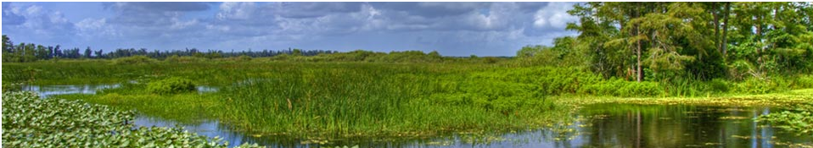
Job Opportunity
Working Title | Lead Civil Engineer
Location | West Palm Beach, Florida
Auto Req ID | 2099BR
Job Description | There are two positions available:  The candidate shall be an experienced Civil or Coastal Professional Engineer that serves in a hands-on Civil and/or Coastal engineering design capacity as a technical expert responsible for the preparation of construction drawings, technical specifications and supporting design reports and calculations, reviewing designs performed by others, evaluating and processing engineering change control requests, provides technical coaching to less seasoned engineering staff and preparing and updating District standards for a broad range of water resource related projects for the Bureau.  Incumbent has working knowledge of standards and practices for related engineering disciplines including Geotechnical, Structural, Mechanical, Electrical, and Environmental. Incumbent demonstrates extensive technical expertise and experience in design development and preparation of design reports, calculations, design plans and technical specifications in support of construction contract document preparation. Engineering services and decisions are made based on a diversified knowledge of theories, concepts, and practices related to the civil and coastal engineering discipline of the professional engineer with an emphasis on design of restoration, flood control and water supply infrastructure. Incumbent serves as the lead designer on multi-disciplined project design teams as required for completion of the scheduled project design deliverables.  Designs are for new construction and refurbishment of aging infrastructure. The types of project work this position will provide engineering design support to will include, but will not be limited to:  1. Water control structures including concrete and/or sheet pile elements, gates and weirs, personnel access platforms/walkways, fall protection.  2. Culvert repairs and/or replacements including box culverts and large diameter pipes.  3. Concrete pump stations, generator buildings, IT shelters and control buildings including precast, tilt wall and cast in place designs.  4. Levees, canal bank repairs, stabilization, dredging, scour repair and environmental restoration.  5. Cofferdams, bypass flows, and other design elements related to construction phasing / sequencing / constructability.  6. Civil sitework for new and existing communication tower facilities and for each of the other above described projects.  Incumbent is responsible for keeping immediate supervisor current on the status of deliverables and assignments.  May assist in developing the District's strategic programs.  Strong analytical, excellent written and oral communications skills are required. Must be good communicator as project work requires collaboration with a variety of professionals, from management to end-user employees, and coordination with designers and reviewers from internal teams, external consultants and numerous other governmental agencies. Also requires strong analytical and creative thinking skills for effective decision-making. Proficiency in Microsoft Office Suite is required; proficiency in AutoCAD is preferred. Experience in supervising a small team of design professionals and engineering during construction experience is preferred. Consistently applied, high attention to detail is necessary for documenting design decisions and following design review procedures. Experience serving as Engineer of Record on projects that have progressed from design inception thru construction close-out is highly preferred. One of the positions will be filled by an incumbent that can demonstrate experience as designer for structural elements of projects of increasing complexity during his or her career progression with an emphasis on specific design experience for some or all the types of projects listed above.  Employment Guidelines  This position may be filled at either the Lead Engineer level, Senior Engineer level, Staff Engineer level or Engineering Specialist IV or III.  Lead Engineer: Typically has a Bachelor's Degree, Master's Degree preferred, from an ABET/EAC accredited program and 8+ years of experience that demonstrates measurable career progression and increased responsibilities within the engineering discipline are required. Discipline for engineering education and experience requirements is Civil, Coastal/Ocean, Environmental, or other related engineering discipline.  Senior Engineer: Typically has a Bachelor's Degree, Master's Degree preferred, from an ABET/EAC accredited program and 6+ years of experience that demonstrates measurable career progression and increased responsibilities within the engineering discipline are required. Discipline for engineering education and experience requirements is Civil, Coastal/Ocean, Environmental, or other related engineering discipline.  Staff Engineer/Engineering Specialist IV: Typically has Bachelor's Degree from an ABET/EAC accredited program and 4+ years’ experience that demonstrates measurable career progression within engineering discipline that can be applied to support the District’s strategic goals and objectives. Discipline for engineering education and experience requirements is Civil, Coastal/Ocean, Environmental, or other related engineering discipline.  Engineer Specialist III: Typically has Bachelor's Degree from an ABET/EAC accredited program and 2+ years’ experience that demonstrates measurable career progression within engineering discipline that can be applied to support the District’s strategic goals and objectives. Discipline for engineering education and experience requirements is Civil, Coastal/Ocean, Environmental, or other related engineering discipline.  Licenses  Professional Engineer license is required for Lead, Senior or Staff Engineer  Valid State of Florida Professional Engineer (PE) license required or ability to obtain Florida PE license within six months of employment by reciprocation of Professional Engineer license from another state.  For Engineering Specialist IV or III:  Continues the process for attaining State of Florida Professional Engineer license by receipt of Engineer-in-Training (EIT) designation and continuing to accumulate acceptable experience for work time licensure requirements. Evidence of successful completion of NCEES Fundamentals of Engineering Exam is preferred.  Valid State of Florida Driver's License required.  Physical Requirements/ Working Environment  Due to the District's response role and in the scope of emergency management, this position may at times be required to provide support before, during, and after major storm events such as hurricanes.  Working environment is typically office oriented but field work in support of projects is required.  To Apply  We encourage you to get to know us better. For more information about our organization, this opportunity and to apply online, please visit www.sfwmd.gov/careers. Job Reference: 2099BR. The SFWMD offers competitive wages and benefits. EOE.

