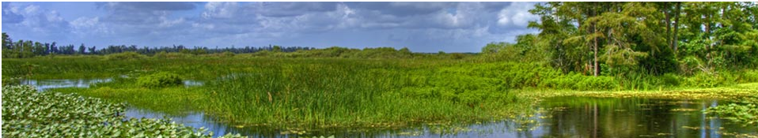
Job Opportunity
Working Title | Senior Engineer
Location | West Palm Beach, Florida
Auto Req ID | 2087BR
Job Description | This position is for a seasoned Professional Engineer to support Everglades Restoration efforts and the Office of Everglades Policy and Coordination through the implementation of projects and programs mandated by the Everglades Forever Act (EFA), the Northern Everglades and the Estuaries Protection Program, and the Everglades Restoration Strategies.  Responsibilities include: managing complex, high-profile projects which support one or more of the District restoration programs; leading diverse project management teams; coordinating with local and regional stakeholders, projects, and rules; conducting complex water quality data analysis taking into account impacts of District operations; assisting with policy and rulemaking activities; reviewing and writing technical documentation and publications, including the South Florida Environmental report; and permitting, field inspections, audits, and other tasks associated with the best management practices (BMPs) nutrient source control program.  Employment Guidelines  Typically has Bachelor's Degree from an ABET/EAC accredited program and 6+ years’ experience that demonstrates measurable career progression within engineering discipline that can be applied to support the District's strategic goals and objectives. Disciplines for engineering education and experience requirements include Agricultural, Water Resources, Civil, Construction, Electrical, Environmental, and Mechanical Engineering.  Licenses  Incumbent has State of Florida Professional Engineer (PE) license and keeps licensure status current.  Valid State of Florida Driver's License required.  To Apply  We encourage you to get to know us better. For more information about our organization, this opportunity and to apply online, please visit www.sfwmd.gov/careers. Job Reference: 2087BR. The SFWMD offers competitive wages and benefits. EOE.

